**[Mei Yang]**

**[4/10/2018]**

**AMRUPT, Spring 2018**

# Goals

Start MATLAB simulation, and focus on the waveform reconstruction in particular

# Problem

Part of the simulation is to simulate the RF signal and the AOA calculation. Therefore, it’s important to simulate the hardware of the system. The entire simulation process will generate RF sine waves, down converts them to IF, quantizes the signals to simulate the ADC stage, and then uses the DF algorithm to calculate the AOA.

# General approach

A signal generator will be used to create sine waves of the form Asin(ωt + φ). The signal carrier frequency needs to be specified to simulate the tag signal transmission. Each of these sine waves corresponds to the signal received at one of the three antennas. The differences in phase offset, φ, will be needed to calculate the AOA. Therefore, the distance from the emitter to the antennas are calculated using the following equation where s is the distance from the antenna to the midpoint between antenna 1 and 2, d is the distance from that midpoint to the emitter, and α is the angle formed at the midpoint.

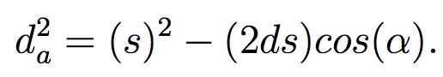

The phase can then be calculated using the following equation where f is the signal’s carrier frequency.



In addition, I will continue studying the github code from other people’s work. I still haven’t finished reading the tutorial on how to use MATLAB Simulink on RTL-SDR. If we can get the hardware this week, I can also start running small testing programs on them.

# Resources and relevant Forum Posts

# <http://www.mwrf.com/test-measurement/generate-complex-radar-signals-awgs>

# <https://pdfs.semanticscholar.org/66f7/d0d7e1bed27acc37b5721f4abe649f9a053e.pdf>

# software defined radio using matlab & simulink and the rtl-sdr pdf